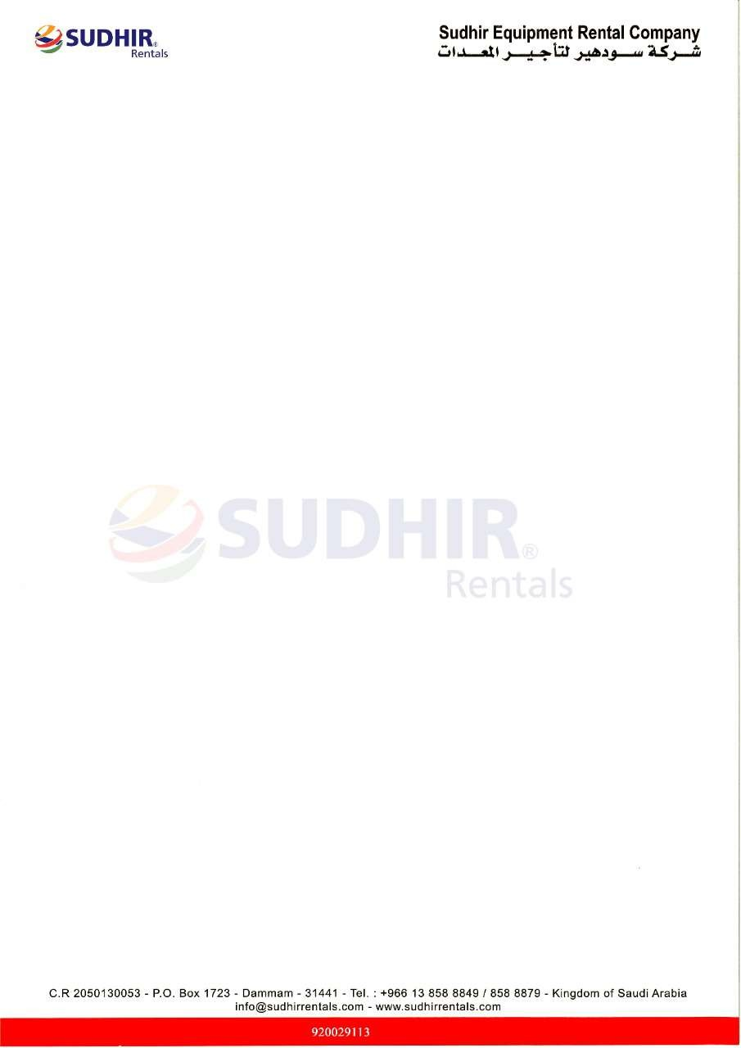

Ownership Certificate
To Whom It May Concern
This is to certify that the following equipment mentioned below are the sole owned by Sudhir Equipment Rental Company.

Equipment | AWP
Brand / Make | Genie
Asset ID | S22SG-769
Model Number | S65
Serial Number | S60D-881
Working Height | 22 Meter
Type | Telescopic
Manufacturing Year | 2017

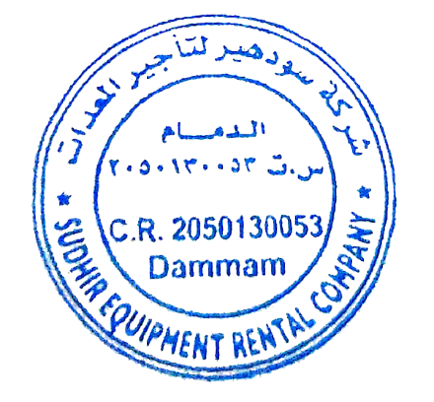
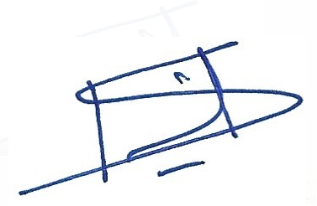

Authorized Signature
Branch Manager
Sudhir Equipment Rental Company
Kingdom of Saudi Arabia

